**Plan Review & Routing Comment Form**

|  |  |
| --- | --- |
| **Project Information** | |
| Project: | Auburn Community Commons - Development Plan |
| Revision: | Preliminary |
| Type: | Development Plan |
| Logos ID: | PROJ-PUBLIC - 2020-00000002 |
| Due Date: | **Jan 15, 2020** |

|  |  |  |  |
| --- | --- | --- | --- |
| **Reviewer Information** | | |  |
| Name: | Amy |  |
| Dept.: | Planning |  |
| Phone: | 925-6449 |  |

|  |
| --- |
| **Comments** *(add more numbers and pages, if necessary)* |

Zoning / Compliance Related

1. This project falls under the definition of “Park, Public” and is permitted in this district.
2. Property is zoned Downtown Commercial and is within the Wellhead Protection Overlay.
3. The County owns the property. How will this be handled?
4. Development Plan approval is required via the Plan Commission. When this project is routed for Plan Commission, we will also route it to DARC (Downtown Auburn Review Committee).
5. Local Building Permit and Indiana Construction Design Release is required. Building Construction Plans will need routed and reviewed in addition to the Development Plan. (These routings may be concurrent.)
6. Provide Structure Height at the highest point.
7. Utility and drainage plans will be required.
8. Will there be a dumpster?
9. We will need more details on any exterior lighting (light specs/details, light locations, photometric plan); signs; and solar components.

Opinion/Design Preferences

1. Security concerns with opened all day, every day
2. We’d strongly encourage incorporating some sort of storage area within the maintenance space. There always seems to be a need for secured storage areas in downtown.
3. Please consider alternatives to the roof line to allow for natural light and air:

* 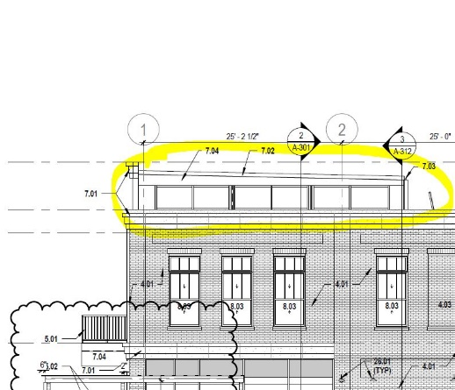Leaving the roof off the open area and designing it to be an open air plaza. It could still have the columns and trusses.
* Similar to TQS, one portion of the roof being taller than the others with some open air vents (see image)

|  |  |  |  |
| --- | --- | --- | --- |
| **Recommended Action** | | |  |
|  |  | Approve | |
|  |  | Approve with Comments | |
|  |  | Revise and Resubmit | |
|  | XX | Other: No significant compliance issues | |

*BPD Use Only*

Rec’d By: ___________

Date: ___________